

**Factory Address: SIYA COATSYS , Plot No,99, At PO Wasuli, Chakan MIDC phase 2, Tal- Khed, Dist -Pune, 410501, Maharashtra, India.**

**Email:info@siyacoatsys.com,** [**Poonam@siyacoatsys.com**](mailto:Poonam@siyacoatsys.com)

**Registered office address: E504,Ayaan Building No2, Ubalenager, Opp.sai satyam park, Wagholi ,Pune**

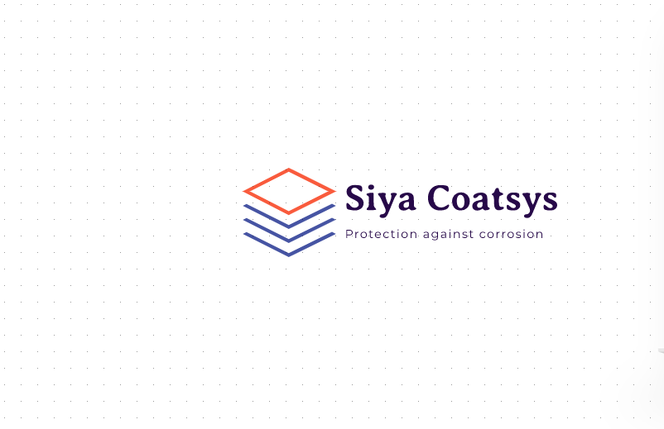

**Protection against corrosion**

**Its our goal to protect your parts from corrosion.**

Providing **corrosion control** is not just about keeping up appearances, it’s also about **preventing further damage** to steel and other metals, especially on the surface. With an **effective anti-corrosion coating**, properly protected surfaces actually ward off the elements that cause corrosion – and keep high-quality materials looking good.



**Slider1**

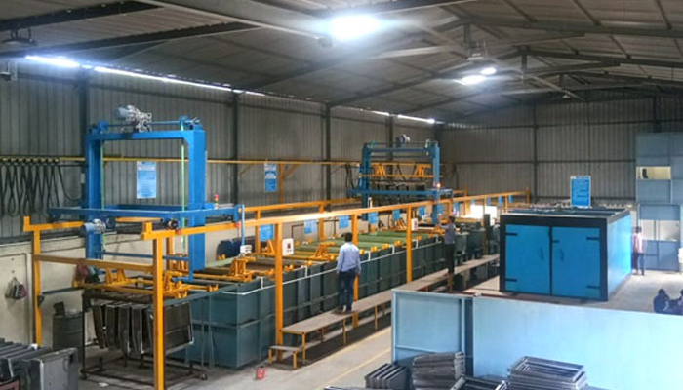

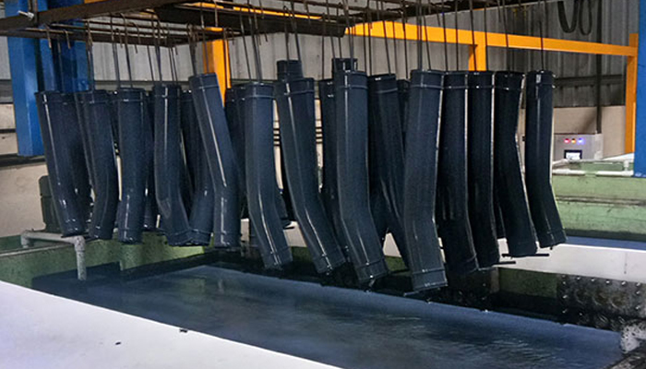

**Slider2**

**Services**

**1.CED Coating**

The **Cathodic Electro Deposition (CED)** process is widely used in the automotive and other industries for better corrosion protection because of its ability to coat complex geometry parts with uniformity.

CED process is industrially used for applying coatings to metal fabricated products. It has been widely used to coat automobile bodies and parts, tractors and heavy equipment, electrical switch gear, appliances, metal furniture, beverage containers, fasteners, and many other industrial products.

**1.1.1CED Coating for**Automobile Parts

**WHEEL RIMS**

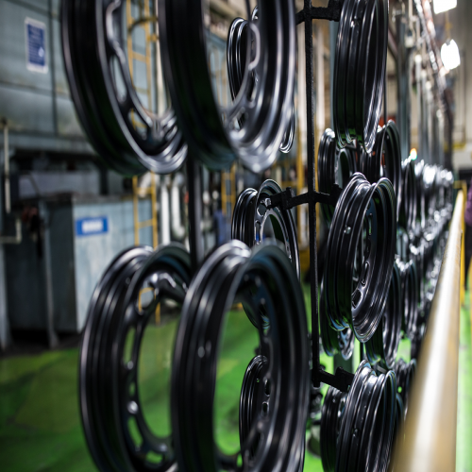

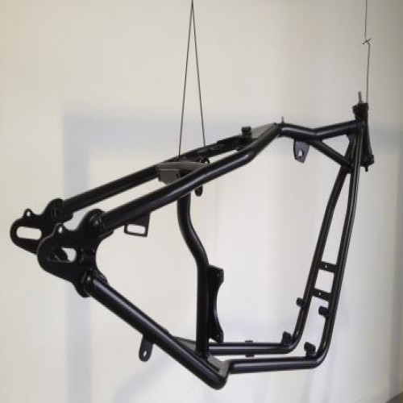

**TWO WHEELER CHASSIS**

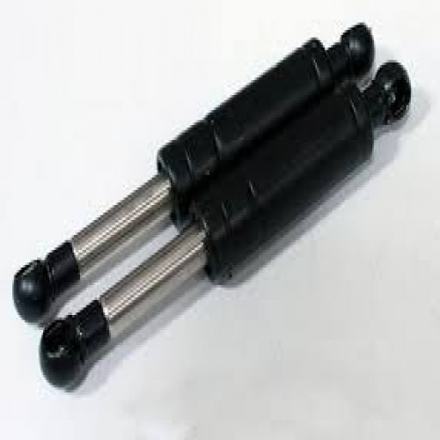

**SUSPENSION**

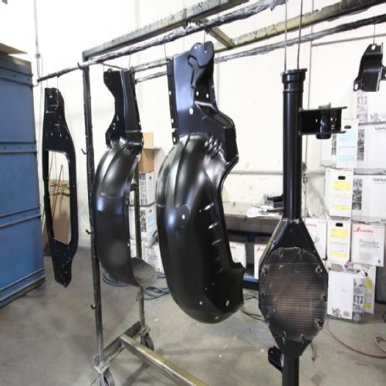

**TWO WHEELER BODY**

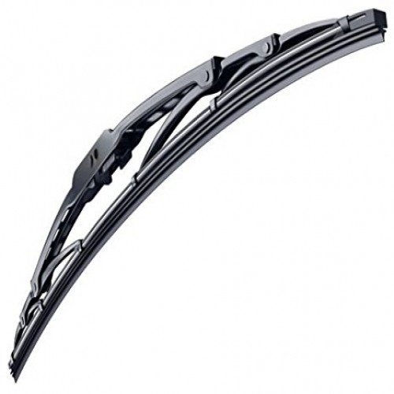**AUTOMOBILE WIPERS**

**1.1.2 CED Coating for Construction Materials**

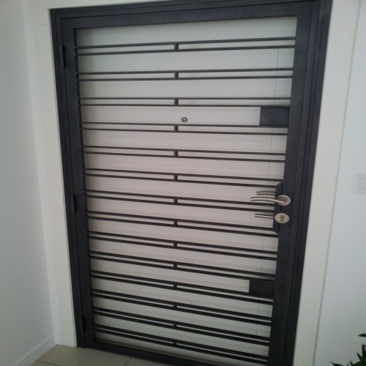

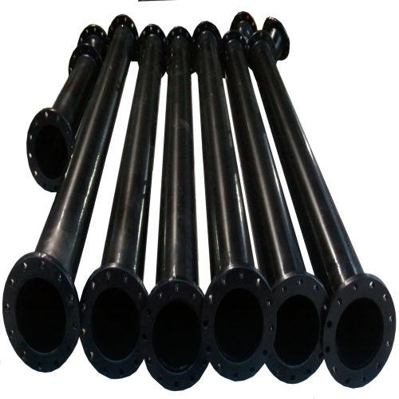

**CED COATING FOR PIPES**

**1.1.3 CED coating for**Sheet Metal Components

We offer **CED Coating Service for Sheet Metal Components** using advanced machinery and superior grade materials that ensure rust resistance of products.

i.e. we provide a rust proof coating on various components.

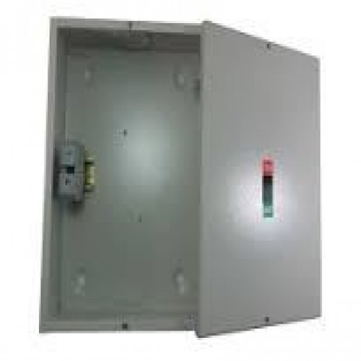

Meter box

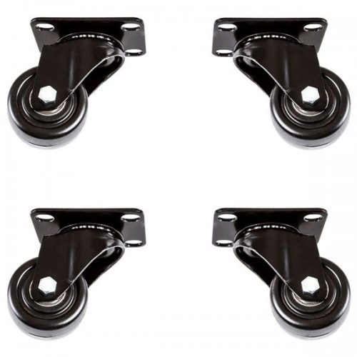

**CASTER WHEEL FRAME**

**1.1.4 CED Coating for Furniture and Accessories**

Our CED coating is ideal for metal furniture, furniture parts and accessories both indoors and outdoor. Whether used for couches, chairs and tables inside the house or office and garden furniture, guaranteed long life of furniture and scratch and rust resistance with smooth finishing.

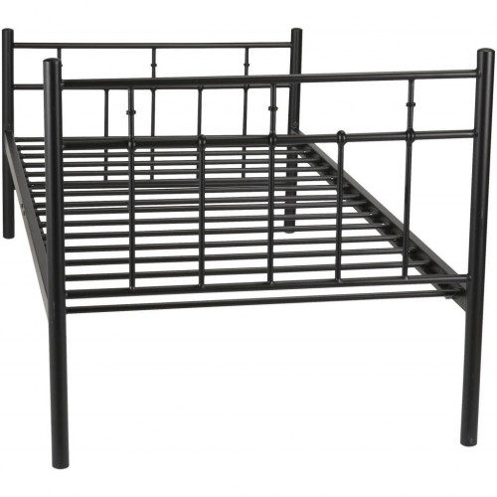

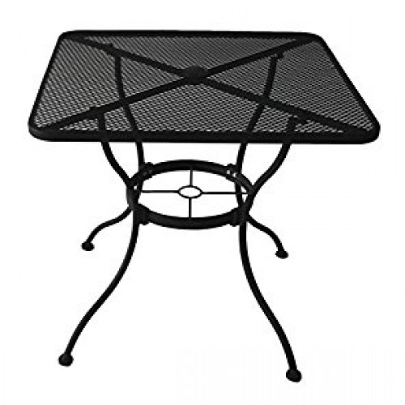

**METAL DINNING TABLE**

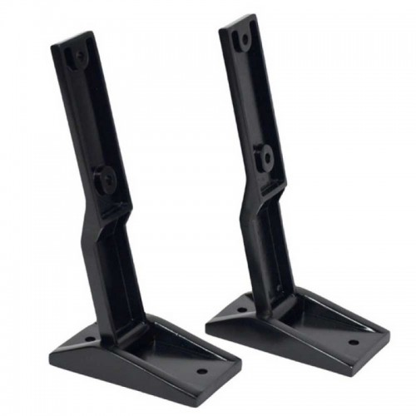

**CED COATING FOR HINGES**

**1.1.4 CED Coating for Fasteners**

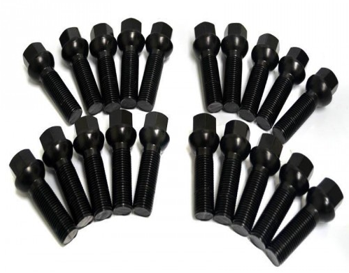

**1.1.5 CED Coating for Casting Products**

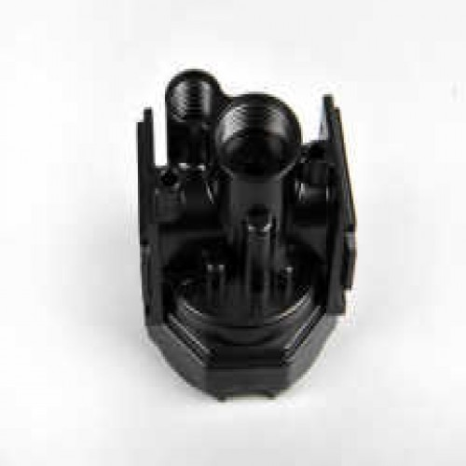

**1.2 Powder Coating**

WE DECORATE YOUR SURFACE WITH POWDER COATING

Powder Coating is pollution-free, eco-friendly, and solvent-less solution. Powder Coating is a method of applying dry paint. It is a type of coating that is applied as a free-flowing dry powder. Powder Coating produces a high specification coating which is hard, erosion-resistant and tough. They are less polluting.

It is usually used to create a strong finish that is tougher than conventional paint.

 The coating is typically applied electrostatically and is then cured under heat to allow it to flow and form a "skin". The powder may be a thermoplastic or a thermoset polymer. It is usually used to create a hard finish that is tougher than conventional paint. Powder coating is mainly used for coating of metals, such as household appliances, aluminium extrusions, drum hardware, and automobile and bicycle parts.

The powder Coating can be done for building materials such as windows, doors, furniture and modular cabin too.

### Powder Coating application process

* Cleaning
* Water Dry Off
* Coating / application
* Curing

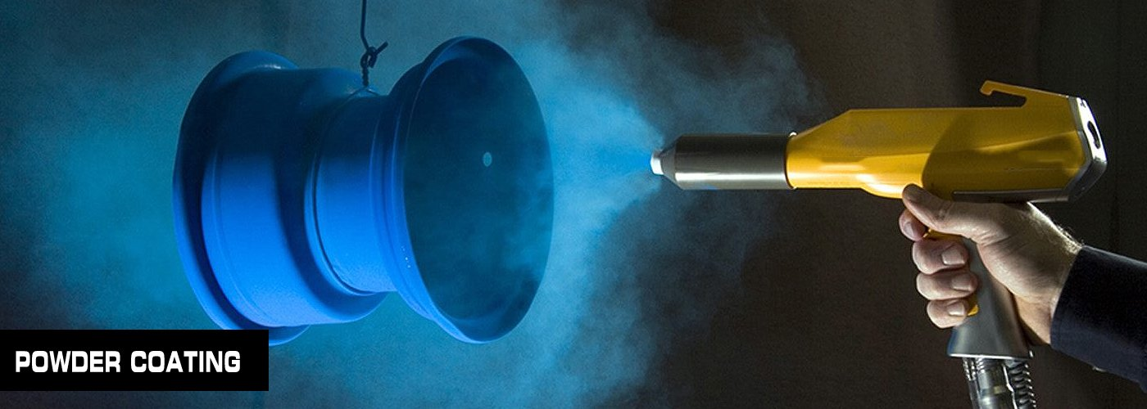

**Clients:**







